PROJECT -33
CALORIES AI
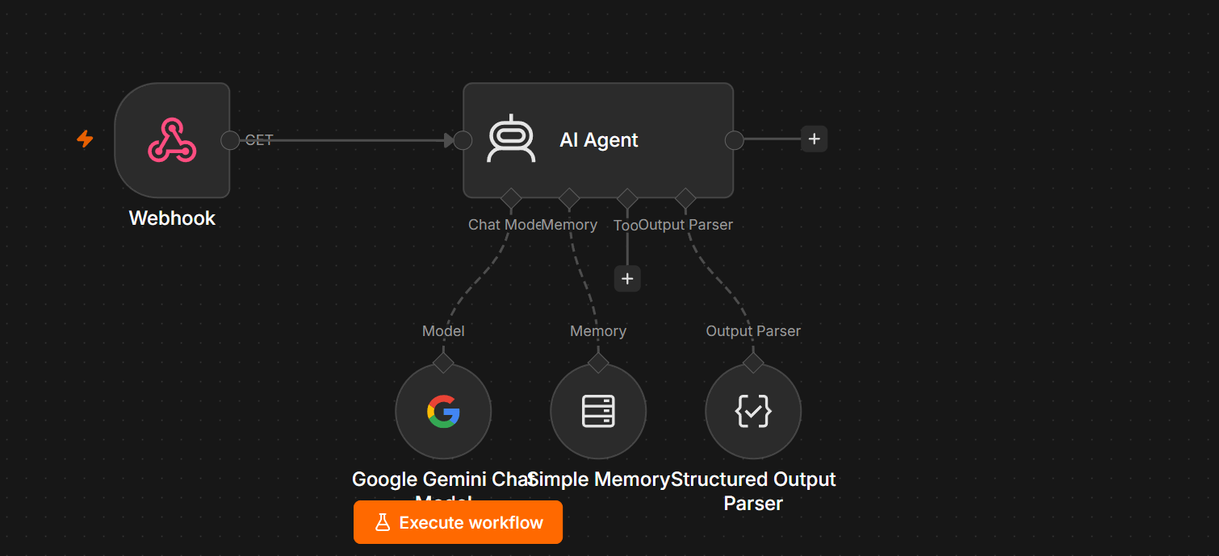
Project Overview
This workflow creates an AI-powered API endpoint using a Webhook. External applications can send requests to the webhook, and the AI Agent processes the input using Google Gemini, remembers previous conversations through Simple Memory, formats the response into a predefined JSON structure using a Structured Output Parser, and returns the response.
This architecture is ideal for integrating AI capabilities into websites, mobile applications, chatbots, CRMs, and automation workflows.

Workflow Architecture
HTTP Request

│

▼

Webhook Trigger

│

▼

AI Agent

┌──────────────┼──────────────┐

▼ ▼ ▼

Google Gemini Simple Memory Structured Output
Chat Model Parser

│

▼

Structured JSON Output

│

▼

API Response to Client

Workflow Components
1. Webhook
Purpose
Acts as the API endpoint that receives HTTP requests from external systems.
Trigger Type
Webhook
HTTP Method
GET
(or POST depending on the implementation)
Example Request
GET /webhook?question=What is Artificial Intelligence?
or
POST

{
"question": "Explain Machine Learning"
}
Output
The webhook forwards the incoming request to the AI Agent.

2. AI Agent
Purpose
The AI Agent acts as the central reasoning engine.
Responsibilities include:
- Understanding user queries
- Sending prompts to Gemini
- Maintaining conversation context
- Producing structured responses
- Coordinating all connected tools

AI Agent Responsibilities
- Interpret natural language
- Use memory for contextual conversations
- Call the Gemini model
- Generate structured output
- Return the final response

3. Google Gemini Chat Model
Purpose
Provides the Large Language Model (LLM).
Responsibilities
- Understands user intent
- Generates intelligent responses
- Supports reasoning
- Produces structured JSON when requested
Example Model
gemini-2.5-flash

4. Simple Memory
Purpose
Stores conversation history.
Benefits
Allows contextual conversations.
Example
User
My favorite programming language is Python.
Later
Which language do I like?
AI
Your favorite programming language is Python.
Without memory, the AI would not remember previous interactions.

5. Structured Output Parser
Purpose
Ensures the AI returns responses in a predefined structure instead of plain text.
This is especially useful for APIs and applications that require machine-readable data.

Example Output Format
{
"answer": "Artificial Intelligence is the simulation of human intelligence by machines.",
"confidence": 0.97,
"category": "Technology"
}
Instead of:
Artificial Intelligence is...

Workflow Execution
Client

│

▼

Webhook

│

▼

AI Agent

│

├────────► Gemini

│

├────────► Memory

│

├────────► Output Parser

│

▼

Formatted JSON

│

▼

Client

Sample Request
{
"question":"Explain Artificial Intelligence"
}

Sample Response
{
"answer":"Artificial Intelligence is the simulation of human intelligence by machines.",
"category":"Technology",
"confidence":0.98
}

AI Agent System Prompt
You are an intelligent AI assistant.

Your responsibilities are:

• Understand user questions.

• Use previous conversation whenever relevant.

• Generate accurate responses.

• Return responses in the required structured format.

• Never invent information.

• If you don't know the answer, clearly state that you don't know.

Be concise, professional, and helpful.

Structured Output Schema
Example schema:
{
"answer": "string",
"category": "string",
"confidence": "number"
}
The parser validates that every AI response matches this schema.

Example Conversations
Example 1
Input
{
"question":"What is AI?"
}
Output
{
"answer":"Artificial Intelligence enables machines to perform tasks that normally require human intelligence.",
"category":"Technology",
"confidence":0.98
}

Example 2
Input
{
"question":"Who discovered gravity?"
}
Output
{
"answer":"Sir Isaac Newton is credited with formulating the law of universal gravitation.",
"category":"Science",
"confidence":0.99
}

Required Credentials
Google Gemini
- Gemini API Key
- Recommended Model:
gemini-2.5-flash

Workflow Features
- Webhook-based REST API
- AI-powered question answering
- Google Gemini integration
- Conversation memory
- Structured JSON responses
- Easy integration with websites and applications
- Suitable for backend automation and AI services

Real-World Use Cases
- AI-powered REST API
- Website chatbot backend
- Mobile app AI assistant
- Customer support automation
- Knowledge base search
- Internal company assistant
- AI microservice
- Document question answering
- CRM and ERP AI integrations

Skills Demonstrated
- AI Agent design in n8n
- Webhook API development
- Google Gemini integration
- Conversation memory management
- Structured output parsing
- JSON schema validation
- REST API workflow design
- AI orchestration and automation

Workflow Summary
Webhook
│
▼
AI Agent
├── Google Gemini Chat Model
├── Simple Memory
└── Structured Output Parser
│
▼
Structured JSON Response
This workflow provides a reusable AI API endpoint that can be connected to websites, mobile apps, Telegram bots, Slack bots, or any system capable of making HTTP requests. It combines natural language understanding, conversational memory, and structured output to make AI responses reliable and easy for other applications to consume.

